ATTACHMENT A

ELECTRONIC EQUIPMENT DATA SHEET SUBMITTAL REQUIREMENTS AND USER GUIDE

SECTION 1

GENERAL INFORMATION

1.1 MINIMUM SYSTEM REQUIREMENTS

The following is required at a minimum to run the electronic equipment data sheet

- A personal computer with a minimum 500MHz processor.
- 256 MB of Random Access Memory (RAM).
- Monitor capable of 1024x768 pixel resolution.
- Microsoft Excel version 2007 or better.

1.2 DEFINITION OF AN ASSET

The Contractor shall be responsible for preparing an electronic database, in a format provided by the Owner, of the project assets being installed under the project and subsequently transferred to the Owner. At a minimum, the asset database shall include, but is not limited to, the following:

- process equipment (particularly those with a process identification tag numbers),
- rotating machinery,
- instrumentation,
- electrical, communications and controls equipment,
- electrical, communications and controls panels,
- vaults,
- pullboxes/handholes,
- wetwells,
- valves,
- specialty fittings,
- tanks,
- pressure vessels, and
- building mechanical and plumbing equipment.

SECTION 2

ELECTRONIC EQUIPMENT DATA SHEET USER GUIDE

The following section outlines the procedures to properly complete the Palm Beach County Electronic Equipment Data Sheet.
2.1 DOWNLOADING THE EQUIPMENT DATA SHEET

The Palm Beach County Electronic Equipment Data Sheet can be downloaded from the Palm Beach County Water Utilities Website using the following procedure:

- Open a web browser to PBC Water Utilities Developer Information page http://discover.pbcgov.org/waterutilities/Pages/Developer-Info.aspx and click on the Minimum Design Standards button. Located in folder 6. Asset Management you will find the instruction sheet and the Equipment Data Sheet.

- The Microsoft Excel spreadsheet will automatically open to the Palm Beach County Equipment Data Sheet Asset Collection Form Tab, Figure 1.

- If a yellow ribbon(s) appears at the top of the spreadsheet make sure to click the button(s) to “Enable Content” and/or “Enable Macros.”

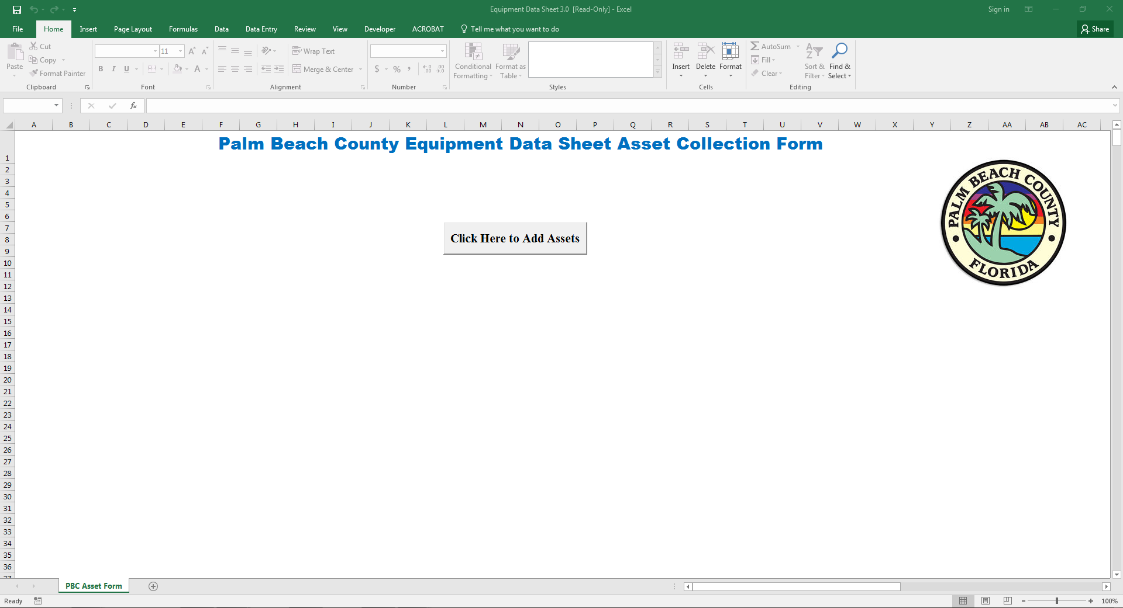
Figure 1 – PBC Equipment Data Sheet Asset Collection Form Tab
2.2 ADDING ASSETS TO THE EQUIPMENT DATA SHEET

To begin adding assets to the electronic equipment data sheet, perform the following procedure:

Step 1: Opening the Palm Beach County Equipment Data Sheet User Form

In the Equipment Data Sheet Asset Collection Form Tab (Figure 1) click the grey rectangular box in the middle of the spreadsheet that reads “Click Here to Add Assets.” This will open up the Equipment Data Sheet User Form, Figure 2.

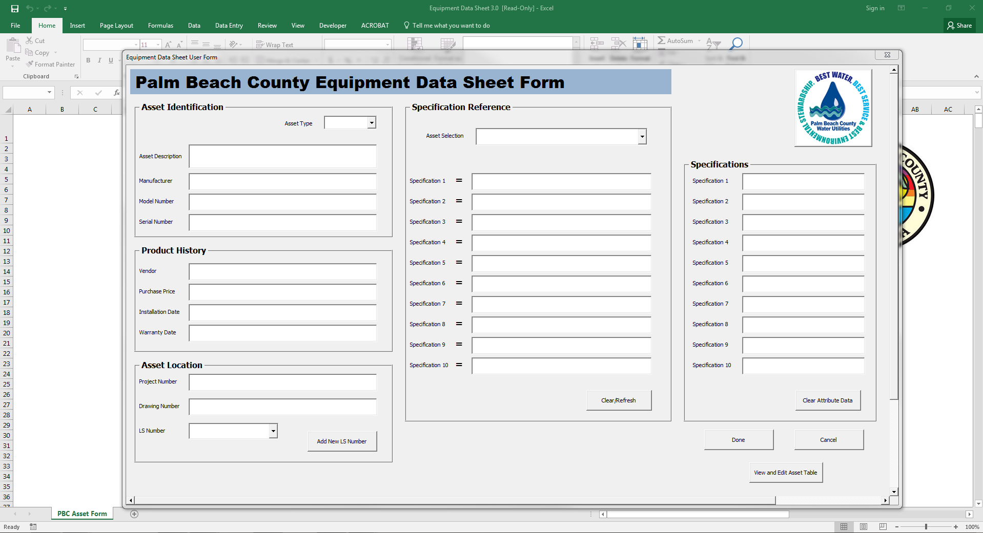
Figure 2 – Equipment Data Sheet User Form
NOTE: Depending on the size and resolution of the user’s monitor, the Equipment Data Sheet User Form may not be the optimal size. The User Form size can be adjusted by clicking and dragging the sides or corners of the User Form until the Form is of the desired size.

NOTE: In order to go back to the Equipment Data Sheet Asset Collection Form tab, the Equipment Data Sheet User Form must first be closed by either clicking on the red “x” in the top right corner of the User Form or clicking the “Cancel” button in the bottom right of the User Form. IF THE USER FORM IS CLOSED WITH THE FORM FIELDS FILLED OUT BEFORE THE “DONE” BUTTON IS PRESSED, THAT DATA WILL BE DELETED AND NOT ADDED TO THE SYSTEM.

Step 2: Completing the Asset Identification, Product History, and Asset Location Fields

Once the Equipment Data Sheet User Form has been opened (Figure 2), information about the asset to be added to the database may be entered into the Asset Identification, Product History, and Asset Location text fields. Those fields include and are defined as follows:

Asset Type – The overall purpose of the asset in regards to the type of utility service the asset is a part of. The dropdown selections for Asset Type include Water, Waste, or Reclaimed. “N/A” may also be chosen if the asset does not fit any of the other categories or if the user is unsure of the asset type.

Asset Description – Describes the asset in a uniquely identifiable way as to differentiate that asset from all other assets that are submitted. ASSET DESCRIPTIONS MUST INCLUDE THE ASSET TAG AND BE OF THE FORM [“ASSET TAG”, “ASSET DESCRIPTOR”]. A list of asset tags is located in Appendix A. Good asset descriptors may include: the assigned name of the asset (e.g. Submersible Pump, Pump 1), the nameplate or tag associated with the asset (e.g. Level Monitor, Filter 2 Level Monitor LIT-11202), or the location of the asset in relation to other surrounding assets (e.g. Gate Valve, Upstream Flow Meter Isolation Valve).

Manufacturer – The parent company that produced the asset.

Model Number – Manufacturer assigned number for the asset’s product series. If there is no model number, the product series name or catalogue number may also be used.

Serial Number – Manufacturer assigned identification number for the asset within its model series.

Vendor – The person(s) or company that sold the asset to the CONTRACTOR. The vendor listed should be the point of contact for any warranty, technical or product maintenance inquiries.

Purchase Price – The material and tax cost of the asset purchased by the CONTRACTOR from the Vendor. Purchase price should not include the costs of labor and installation.

Installation Date – The calendar date of final installation of the asset by the CONTRACTOR. Installation date should be entered in the form [mm/dd/yyyy].

Warranty Date – The calendar date of final warranty as guaranteed by the manufacturer, if any exist. The warranty date should be entered in the form [mm/dd/yyyy].

Project Number – The Palm Beach County Water Utilities Department (PBCWUD) project number as specified on the cover of the contract documents.

LS Number – The assigned PBCWUD identification number for the lift station site. If the asset is added to an existing lift station, the lift station number may be selected from the dropdown list. If the asset is added to a new lift station, a new lift station number may be added to the list by pressing the “Add New LS Number” button which will open up the Add/Replace LS Number Form, Figure 3. Follow the prompts on the Add/Replace LS Number form to add a new lift station to the list, or replace an existing lift station with a new lift station number.

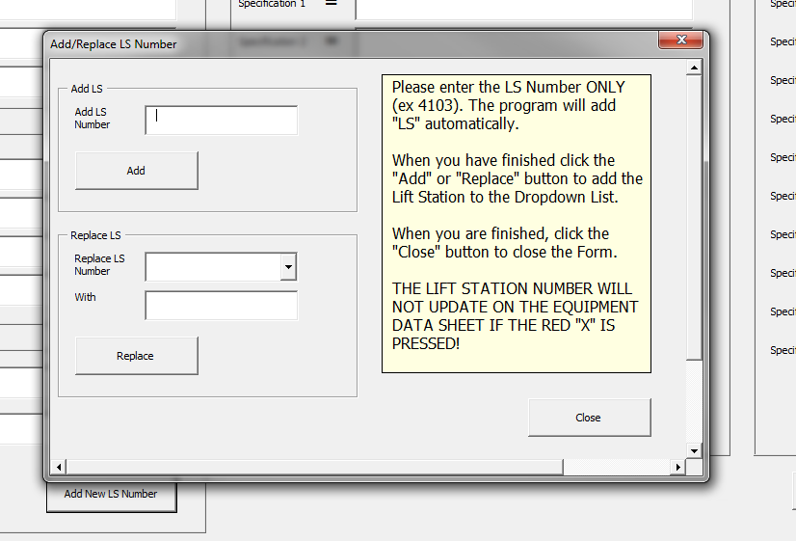
Figure 3 – Add/Replace LS Number Form
NOTE: The first time a new lift station is added/replaced to the system, the Equipment Data Sheet User Form must be refreshed before the new lift station number will appear in the LS Number dropdown list. To do this simply close and re-open the Equipment Data Sheet User Form by pressing the “Cancel” button and then again clicking on the “Click Here to Add Assets” button. Refreshing the form will refresh the text fields, so it is advised to add/replace the lift station number BEFORE adding data for a new asset.

Step 3: Using the Specification Reference Tool to Complete the Asset Specification Section

The Specification Reference Tool is a dynamic reference table that allows the user to quickly and easily locate additional attributes that are specific to the asset, Figure 4. The procedure for completing the Asset Specification section are as follows:

- Locate the asset from the Asset Selection dropdown list. Items in the dropdown list are the same as the Asset Tag list located in Appendix A, and the selection should match the first part of the “Asset Description” exactly. Items in the Asset Selection dropdown list may be keyword searched by typing in the first few letters of the asset. The reference table may be cleared by clicking the “Clear/Refresh” button.

  - The specification reference fields will populate automatically once the asset is selected from the Asset Selection dropdown list. These are the specific asset attributes to be determined by the CONTRACTOR.

- Complete the applicable text fields in the Specifications Section. Specification 1 should correspond to the Specification 1 reference, Specification 2 with the Specification 2 reference, and so forth. The specifications may be cleared by clicking the “Clear Attribute Data” button.

  - If a specification has a specific unit it will be denoted next to the specification reference with a bracket [ ] and should be included.

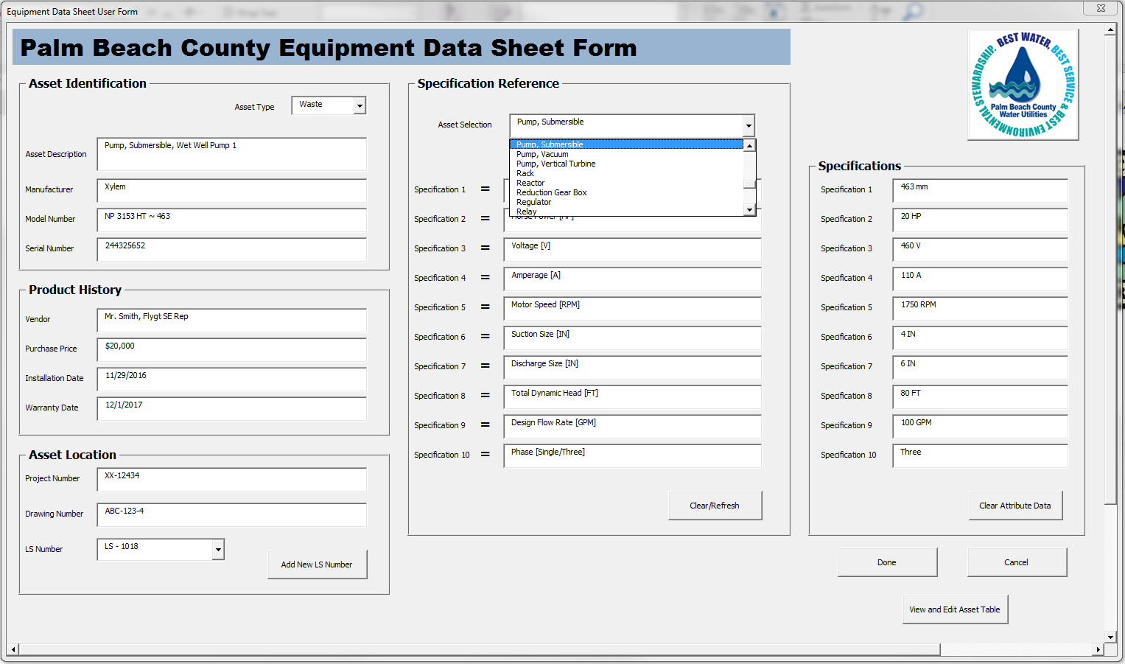
Figure 4 – Specification Reference Tool

Step 4: Sending the Asset Data to the Asset Table

Once the Asset Identification, Product History, Asset Location, and Specification Fields are complete, and the Asset is ready to be added to the system, simply press the “Done” button located on the bottom right hand corner of the Equipment Data Sheet User Form, Figure 5. At that point the data will be sent to the asset table, all of the fields in the Equipment Data Sheet with the exception of the Asset Type will be refreshed, and the user can begin adding the next asset.

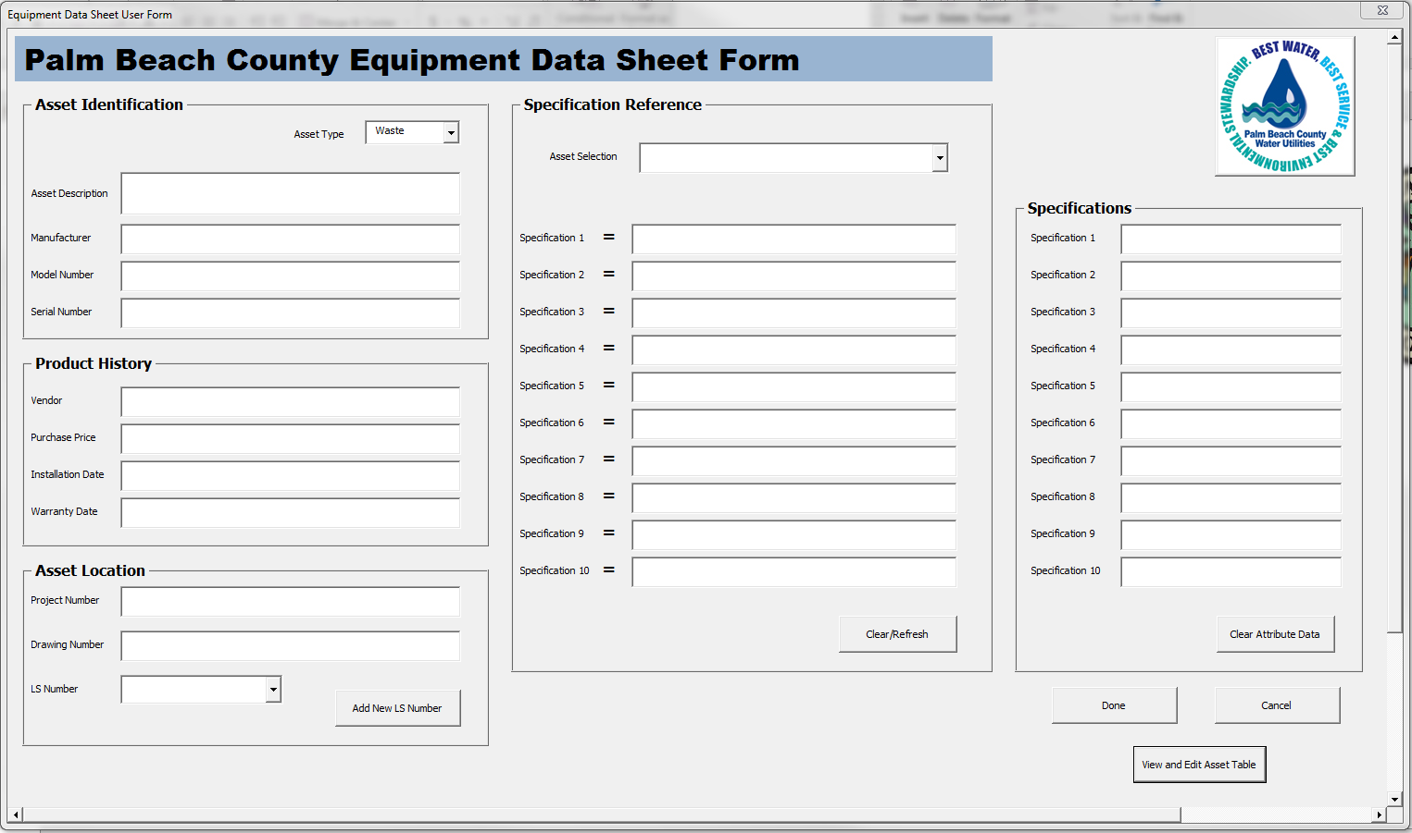
Figure 5 – Sending Data to the Asset Table
2.3 VIEWING AND EDITING DATA IN THE ASSET TABLE

Data that has been sent to the asset table can be viewed and edited at any time in the Asset Table Lookup Form (Figure 6) by clicking on the “View and Edit Asset Table” button located under the “Done” button in the lower right hand corner of the Equipment Data User Form (Figure 2).

The Asset Table Lookup Form allows the user to view the entire asset table to date in a tabular form and make any edits as necessary. To make edits to the asset table perform the following procedure, Figure 7:

- Navigate and select the desired row of data in the asset table by either using the scroll bars in the asset table window and clicking on row, or by clicking the forward and back buttons (<<< / >>>) located in the bottom left hand corner of the Lookup Form.

- The selected data will be highlighted in blue and will automatically populate Asset Selection Value fields below the asset table window.

- To make an edit select the desired Asset Selection field(s) and overwrite the data by deleting the existing data and entering in the new correct data.

- Next click the “Click to Edit Table” button located at the bottom of the Asset Table Lookup Form and the asset table will be updated with the new data entered in the Asset Selection Field(s).

- To exit the Asset Table Lookup Form and resume adding assets to the Equipment Data User Form, simply press the “Close” button in the bottom right hand corner.

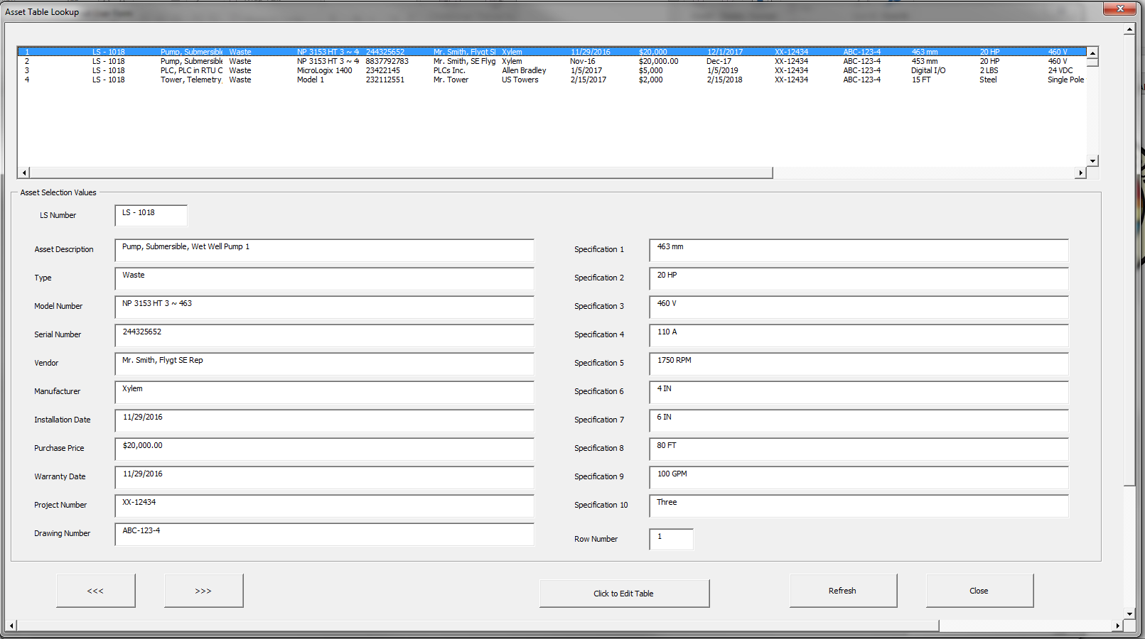
Figure 6 – Asset Table Lookup Form
1
3
2

Figure 7 – Steps to Edit Data Within the Asset Table Lookup Form

SECTION 3

ELECTRONIC EQUIPMENT DATA SHEET SUBMITTAL PROCEDURE

All contractors are responsible of submittal per the contract documents of the awarded project contract.

APPENDIX A

ASSET TAG LIST

- Actuator
- Air Conditioning (Package)
- Air Handler
- Air Release Valve
- Alarm
- Ammoniator
- Analyzer
- Auger
- Auto Flusher
- Automatic Transfer Switch
- Backflow Preventer
- Bar Screen
- Bar Screen Shock Relay
- Battery Charger Unit
- Belt Filter Press
- Blower
- Boat
- Boat, Pontoon
- Boiler
- Breaker
- Burner
- Calibration Column
- Camera
- Cart
- Cart, Golf
- Cart, Passenger
- Cart, Utility
- Catalyst Monitor
- Catalytic Converter
- Channel Monster
- Compressor
- Condenser
- Contactor
- Container
- Control Cabinet
- Control Panel
- Controller
- Conveyor
- Dampener
- Defibrillator
- Diffuser
- Display
- Distiller
- Dryer
- Electrical Panel
- Elevator
- Emergency Shower Eye Wash
- Enclosure
- Engine
- Exhaust Fan
- Fencing
- Filter
- Filter Hood
- Fire Alarm
- Flame Arrestor
- Flow Meter
- Flow Meter Controller
- Flow Transmitter
- Fork Lift
- Fuel Monitor
- Furnace
- Gas Cleaner
- Gate
- Gate Operator
- Gear Box
- Generator
- Grate
- Grit Classifier
- Grit Separator
- Grounding Reel, Retractable
- Harmonic Filter
- Hatch
- Heat Exchanger
- Heater
- Heating Panel
- Heating Ventilation & Air Conditioning (HVAC)
- Hoist
- Hopper
- Hydrant
- Hydraulic Pressure Booster
- Hydrocyclone
- Ice Machine
- Incubator
- Injector
- Inverter
- Ladder
- Level Monitor
- Level Transmitter
- Lift
- Light
- Light Pole
- Lime Silo
- Load Bank
- Macerator
- Manhole
- Mixer
- Monitor
- Motor
- Odor Control Unit
- Oven/Lab
- Ozone Destructor
- Panel
- pH Meter
- Pipe
- Pipe, Clay
- Pipe, DI
- Pipe, Fiberglass Reinforced Plastic
- Pipe, Galvanized
- Pipe, High Density Polyethylene
- Pipe, PVC
- Pipe, Stainless
- Portable Fire Extinguisher
- Power Conditioner
- Power Disconnect
- Power Monitor
- Pressure Transmitter Indicator
- Pressure Vessel Train
- Pressure Washer
- Probe
- Programmable Logic Controller
- Pump
- Pump, Centrifugal
- Pump, Diaphragm
- Pump, Fuel
- Pump, Positive Displacement
- Pump, Progressive Cavity
- Pump, Submersible
- Pump, Vacuum
- Pump, Vertical Turbine
- Rack
- Reactor
- Reduction Gear Box
- Regulator
- Relay
- Remote Transmitter Unit
- Roll Up Door
- Roto Screen
- Rotameter
- Sampler
- Scale
- Scraper Mechanism Clarifier
- SDI Meter
- Sensor
- Separator
- Silencer
- Slaker
- Sludge Press
- Solar Panel
- Solenoid
- Starter
- Strainer
- Surge Voltage Protector
- Switch, Limit
- Switch, Transfer
- Switchgear
- Tank
- Tank, Air
- Tank, Chemical
- Tank, Fuel
- Tank, Hydropneumatic
- Tank, Reclaim
- Tank, Surge
- Tank, Water
- Temperature Transmitter
- Thickener
- Tower
- Trailer
- Transceiver
- Transformer
- Uninterrupted Power Supply
- Valve
- Valve, Butterfly
- Valve, Check
- Valve, Gate
- Valve, Plug
- Valve, Pressure Relief
- Valve, Pressure Sustaining
- Vapor, Heater
- Variable Frequency Drive
- Venturi
- Vibration Transmitter
- Vibrator
- Volt Meter
- Waste Gas Torch
- Water Heater
- Water Meter
- Water Softener
- Water Softener Timer
- Weather Station
- Well
- Well, Deep Injection
- Well, Monitoring
- Well, Production
- Wet Well
- Winch

